Uhtred's Speech — Per-Line Cut Sheet
Source: "Uhtred's Final Speech – Honoring our Ancestors – The Last Kingdom [with Subs En/Br]", channel Hidden by Leaves, posted 2022‑07‑02. Runtime: 1:14 (74.0 s) Output: 22 single-line cuts, each with in/out points, a title, and descriptor metadata.

0. Method and honesty notes
- Anchor points are real. The video ships a subtitle track whose cue starts are: 0:00, 0:06, 0:14, 0:21, 0:29, 0:37, 0:47, 0:55, 1:04, 1:12. Those ten boundaries are taken verbatim from the caption track and are trustworthy.
- Intra-cue splits are estimates. Most cues pack two or three sentences into one 6–10 s block. I divided each cue by word count, weighted for delivery pace, so a line's in/out point can drift roughly ±0.3–0.5 s. Nudge them in your editor against the waveform.
- Caption errors corrected. The subtitle track reads "raised the day" and "for days" — speech-recognition slips for "a Dane" and "for Danes". Restored below. Everything else follows the caption text.
- Tail cue. The final cue at 1:12 shows only the fragment "you", almost certainly a subtitle overlap or trailing card. Treated as a hold, not a line.
- Wisdom sayings are editorial distillations, not dialogue. They are my one-line abstracts of each beat. Do not caption them as quotes from the show.

How I read your header schema
Your term | Field in this sheet
Titelit acceptor | TITLE — the line itself, promoted to a heading
Grip in cut | GRIP — the in-point / out-point pair
Introduction descriptor pre | PRE — the framing beat before the title lands
After title … individuality | POST — what the line does on its own, read in isolation
Wisdom saying | WISDOM — distilled maxim (editorial)
Division in Year | DIVISION — the act the line sits in (five-act reading of the speech)
Acceptor to years in rising stability | CLASS: Stabilizer — line increases cohesion
Distabilizor acceptor | CLASS: Destabilizer — line names fracture, fear, or grievance

If your schema means something narrower — e.g. "Division in Year" as literal year-markers, or "acceptor" as a formal grammar term — tell me and I'll rebuild the columns.

1. Master cut table
# | In | Out | Dur | Line (= title) | Class | Division
01 | 0:00.0 | 0:04.3 | 4.3 | For I speak to you as a man who has lived among you | Stabilizer | I — Credential
02 | 0:04.3 | 0:06.0 | 1.7 | Your gods are my gods | Stabilizer | I — Credential
03 | 0:06.0 | 0:09.3 | 3.3 | I was born a Saxon but raised a Dane | Stabilizer | I — Credential
04 | 0:09.3 | 0:11.1 | 1.8 | For years that divided me | Destabilizer | I — Credential
05 | 0:11.1 | 0:14.5 | 3.4 | But perhaps the Gods have led us all here | Stabilizer | I — Credential
06 | 0:14.5 | 0:18.0 | 3.5 | For I will offer you a bargain | Stabilizer | II — The Bargain
07 | 0:18.0 | 0:21.0 | 3.0 | I ask you to fight now | Stabilizer | II — The Bargain
08 | 0:21.0 | 0:23.0 | 2.0 | For me and for Northumbria | Stabilizer | II — The Bargain
09 | 0:23.0 | 0:29.0 | 6.0 | And if we take these lands we will be taking them for Saxons and for Danes | Stabilizer | II — The Bargain
10 | 0:29.0 | 0:34.3 | 5.3 | Follow me and all Danes will live in peace here | Stabilizer | III — Guarantees
11 | 0:34.3 | 0:37.0 | 2.7 | I swear this to you | Stabilizer | III — Guarantees
12 | 0:37.0 | 0:40.6 | 3.6 | Danes will not be hunted nor live in forests | Destabilizer | III — Guarantees
13 | 0:40.6 | 0:43.0 | 2.4 | You will have lands and homes | Stabilizer | III — Guarantees
14 | 0:43.0 | 0:47.0 | 4.0 | And I ask you not to do this for Saxons | Destabilizer | III — Guarantees
15 | 0:47.0 | 0:50.6 | 3.6 | Do it for what your forebears came here for | Stabilizer | IV — Ancestors
16 | 0:50.6 | 0:55.0 | 4.4 | For the reason they risked their lives and crossed the seas | Stabilizer | IV — Ancestors
17 | 0:55.0 | 0:57.6 | 2.6 | To make a homeland | Stabilizer | IV — Ancestors
18 | 0:57.6 | 1:01.4 | 3.8 | Follow me in this, I swear | Stabilizer | V — The Seal
19 | 1:01.4 | 1:04.0 | 2.6 | You have my word | Stabilizer | V — The Seal
20 | 1:04.0 | 1:07.4 | 3.4 | As a Saxon | Stabilizer | V — The Seal
21 | 1:07.4 | 1:12.0 | 4.6 | And as a Dane | Stabilizer | V — The Seal
22 | 1:12.0 | 1:14.0 | 2.0 | (tail — caption fragment "you"; hold or trim) | — | —

Durations sum to 74.0 s with no gaps and no overlaps, so this tiles the whole clip.

2. Descriptor pairs
Each entry: PRE (framing before the title) → TITLE → POST (what the line does alone) · WISDOM.
01 · 0:00.0–0:04.3 PRE: Cold open. No music sting, crowd noise under the voice — the audience is already assembled and sceptical. POST: Establishes the speaker's standing by biography rather than rank. Read alone, it is a claim to be heard. WISDOM: Authority borrowed from shared life outlasts authority claimed from office.
02 · 0:04.3–0:06.0 PRE: Straight address, no hedging. POST: Clears the religious objection before it can be raised. Removes the strongest reason to refuse. WISDOM: Settle the sacred question first, or it settles the argument against you.
03 · 0:06.0–0:09.3 PRE: The thesis arrives. Delivery slows on the two nouns. POST: The hinge of the entire speech — identity presented as a bridge, not a fault line. WISDOM: Birth is a fact; upbringing is a loyalty. Whoever holds both holds the room.
04 · 0:09.3–0:11.1 PRE: Voice drops. Short line, heavy. POST: Concedes a wound. Buys credibility by admitting the cost of the split. WISDOM: Name the division you carry, or it will be named for you.
05 · 0:11.1–0:14.5 PRE: The pivot — "but". Breath before "perhaps". POST: Reframes accident as providence and hands the audience a part in a larger story. WISDOM: What divided you may be the road that delivered you.
06 · 0:14.5–0:18.0 PRE: Register shifts from confession to commerce. POST: Signals terms, not a plea. Sets the listener up to weigh rather than obey. WISDOM: People move for offers, not for orders.
07 · 0:18.0–0:21.0 PRE: Imperative, no softening. POST: The ask, stated plainly and early — no burying the request in the third act. WISDOM: Ask for the thing you actually want, in the first breath you can spare.
08 · 0:21.0–0:23.0 PRE: Two stakes named in five words. POST: Personal loyalty and territorial cause welded together, so refusal costs twice. WISDOM: Bind your name to the land's name and refusal becomes expensive.
09 · 0:23.0–0:29.0 PRE: Conditional "if" — the listener is invited into the premise. POST: The shared-spoils clause. The bargain's actual mechanism: conquest framed as joint property. WISDOM: A prize split in advance is cheaper than a prize defended afterwards.
10 · 0:29.0–0:34.3 PRE: Promise, forward-leaning. POST: First explicit guarantee — peace, and specifically peace here. WISDOM: Promise the condition, not the reward; conditions are what people fear losing.
11 · 0:34.3–0:37.0 PRE: Oath marker, slower. POST: Seals the guarantee with the speaker's own credit. WISDOM: An unsworn promise is a rumour.
12 · 0:37.0–0:40.6 PRE: Names the fear directly — hunted, hidden. POST: Speaks to a specific remembered harm rather than abstract liberty. WISDOM: Address the harm they have actually suffered, or your remedy sounds theoretical.
13 · 0:40.6–0:43.0 PRE: Concrete nouns, plain delivery. POST: Material promise — land and home. The measurable half of the offer. WISDOM: Give the abstract promise a floor plan.
14 · 0:43.0–0:47.0 PRE: Negation, deliberately uncomfortable. POST: Releases the audience from duty to the other side. Disarms resentment by removing obligation. WISDOM: Excusing someone from a debt wins more than reminding them of it.
15 · 0:47.0–0:50.6 PRE: Turn outward, to the dead. POST: Switches the motive from loyalty owed to legacy inherited. WISDOM: When present duty is weak, borrow weight from the ancestors.
16 · 0:50.6–0:55.0 PRE: The crossing — sea imagery, longer line. POST: Reactivates the migration story as living memory rather than history. WISDOM: A journey retold becomes a mandate.
17 · 0:55.0–0:57.6 PRE: The shortest line in the speech. Space around it. POST: The payload. Names the real object of desire that everything prior was circling. WISDOM: Say the true want in four words and stop talking.
18 · 0:57.6–1:01.4 PRE: Return of the call, now earned. POST: Second oath. Closes the loop opened at line 06. WISDOM: Repeat the ask only after you have paid for it.
19 · 1:01.4–1:04.0 PRE: Quiet, almost private. POST: The bond offered in the smallest possible register. WISDOM: End on the smallest promise; it is the hardest to break.
20 · 1:04.0–1:07.4 PRE: Held beat before the phrase completes. POST: Half of a doubled identity, deliberately left hanging. WISDOM: Split the seal in two and the second half lands harder.
21 · 1:07.4–1:12.0 PRE: Longest hold in the clip for the fewest words — 4.6 s across four. POST: The reconciliation. The two halves of line 03 returned as one signature. WISDOM: Close by returning to the line you opened with, and let silence sign it.
22 · 1:12.0–1:14.0 PRE: Caption fragment only. POST: Not a line. Either subtitle overlap or the tail of the closing shot — hold as an outro card or trim to 1:12.0.

3. Lines as standalone titles
Clean, title-cased, ready to paste as chapter markers or thumbnail text:
- For I Speak to You as a Man Who Has Lived Among You
- Your Gods Are My Gods
- I Was Born a Saxon but Raised a Dane
- For Years That Divided Me
- But Perhaps the Gods Have Led Us All Here
- For I Will Offer You a Bargain
- I Ask You to Fight Now
- For Me and for Northumbria
- For Saxons and for Danes
- All Danes Will Live in Peace Here
- I Swear This to You
- Not Hunted, Nor Living in Forests
- Lands and Homes
- Not for Saxons
- What Your Forebears Came Here For
- They Risked Their Lives and Crossed the Seas
- To Make a Homeland
- Follow Me in This
- You Have My Word
- As a Saxon
- And as a Dane
Note that #9, #12, #14, #16 and #17 are trimmed paraphrases of the full lines in §1 — shortened so they function as titles. The full verbatim text stays in the master table.

4. Pacing profile
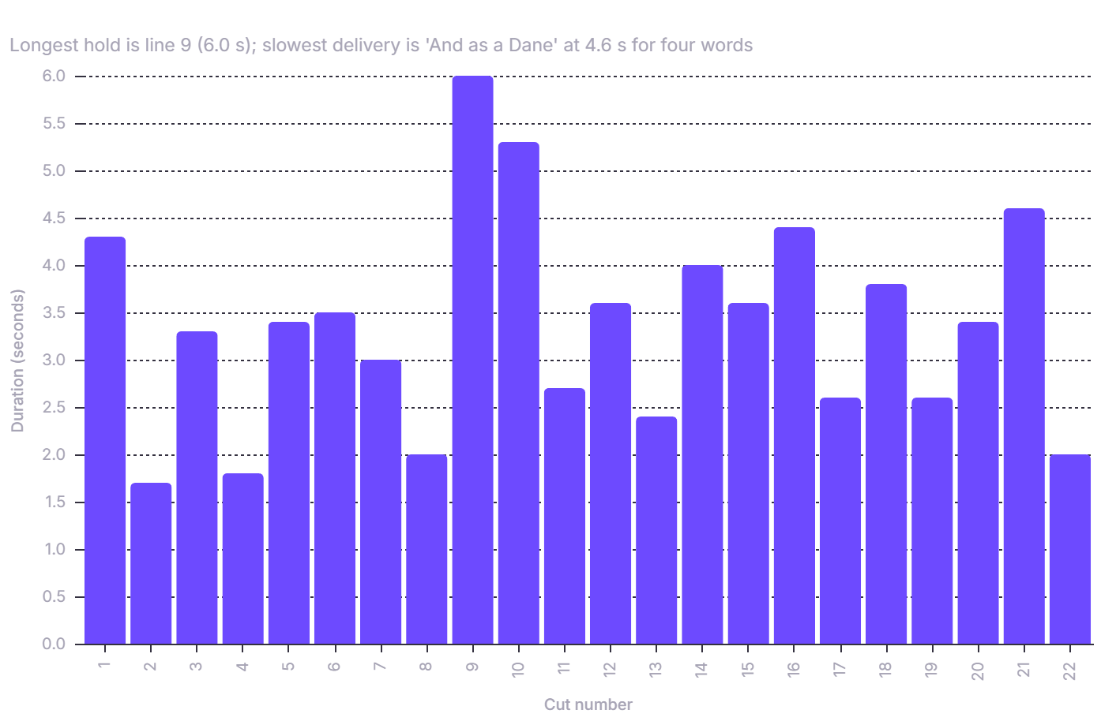
Reading the profile: the two peaks at 9 and 10 are the bargain's spine — the shared-spoils clause and the promise of peace. The dip at 17 is the four-word payload. The rise at 21 is the deliberate slow-down that ends the clip.

5. Export formats

5a. Subtitle file (save as uhtred_lines.srt)
1
00:00:00,000 --> 00:00:04,300
For I speak to you as a man who has lived among you
2
00:00:04,300 --> 00:00:06,000
Your gods are my gods
3
00:00:06,000 --> 00:00:09,300
I was born a Saxon but raised a Dane
4
00:00:09,300 --> 00:00:11,100
For years that divided me
5
00:00:11,100 --> 00:00:14,500
But perhaps the Gods have led us all here
6
00:00:14,500 --> 00:00:18,000
For I will offer you a bargain
7
00:00:18,000 --> 00:00:21,000
I ask you to fight now
8
00:00:21,000 --> 00:00:23,000
For me and for Northumbria
9
00:00:23,000 --> 00:00:29,000
And if we take these lands we will be taking them for Saxons and for Danes
10
00:00:29,000 --> 00:00:34,300
Follow me and all Danes will live in peace here
11
00:00:34,300 --> 00:00:37,000
I swear this to you
12
00:00:37,000 --> 00:00:40,600
Danes will not be hunted nor live in forests
13
00:00:40,600 --> 00:00:43,000
You will have lands and homes
14
00:00:43,000 --> 00:00:47,000
And I ask you not to do this for Saxons
15
00:00:47,000 --> 00:00:50,600
Do it for what your forebears came here for
16
00:00:50,600 --> 00:00:55,000
For the reason they risked their lives and crossed the seas
17
00:00:55,000 --> 00:00:57,600
To make a homeland
18
00:00:57,600 --> 00:01:01,400
Follow me in this, I swear
19
00:01:01,400 --> 00:01:04,000
You have my word
20
00:01:04,000 --> 00:01:07,400
As a Saxon
21
00:01:07,400 --> 00:01:12,000
And as a Dane

5b. Batch split with ffmpeg
Save the timecodes once, then loop. This is the fast, stream-copy version — near-instant, but cuts snap to the nearest keyframe, so expect up to ~1 s of drift:
#!/usr/bin/env bash
set -euo pipefail
IN="input.mp4"
OUTDIR="cuts"
mkdir -p "$OUTDIR"
# "in|out|slug" — in/out in HH:MM:SS.mmm
MAP=(
"00:00:00.000|00:00:04.300|01_for-i-speak-to-you"
"00:00:04.300|00:00:06.000|02_your-gods-are-my-gods"
"00:00:06.000|00:00:09.300|03_born-a-saxon-raised-a-dane"
"00:00:09.300|00:00:11.100|04_for-years-that-divided-me"
"00:00:11.100|00:00:14.500|05_gods-have-led-us-all-here"
"00:00:14.500|00:00:18.000|06_offer-you-a-bargain"
"00:00:18.000|00:00:21.000|07_fight-now"
"00:00:21.000|00:00:23.000|08_for-me-and-northumbria"
"00:00:23.000|00:00:29.000|09_saxons-and-danes"
"00:00:29.000|00:00:34.300|10_live-in-peace-here"
"00:00:34.300|00:00:37.000|11_i-swear-this-to-you"
"00:00:37.000|00:00:40.600|12_not-hunted-nor-forests"
"00:00:40.600|00:00:43.000|13_lands-and-homes"
"00:00:43.000|00:00:47.000|14_not-for-saxons"
"00:00:47.000|00:00:50.600|15_what-forebears-came-for"
"00:00:50.600|00:00:55.000|16_crossed-the-seas"
"00:00:55.000|00:00:57.600|17_to-make-a-homeland"
"00:00:57.600|00:01:01.400|18_follow-me-in-this"
"00:01:01.400|00:01:04.000|19_you-have-my-word"
"00:01:04.000|00:01:07.400|20_as-a-saxon"
"00:01:07.400|00:01:12.000|21_and-as-a-dane"
)
for row in "${MAP[@]}"; do
IFS='|' read -r ss to slug <<< "$row"
ffmpeg -hide_banner -loglevel error \
-ss "$ss" -to "$to" -i "$IN" \
-c copy "$OUTDIR/${slug}.mp4"
done
For frame-accurate cuts, re-encode instead — slower but exact:
ffmpeg -hide_banner -ss "$ss" -to "$to" -i "$IN" \
-c:v libx264 -crf 18 -preset veryfast -c:a aac -b:a 192k \
"$OUTDIR/${slug}.mp4"
Or make one file per line with the subtitle track burned in:
ffmpeg -hide_banner -ss "$ss" -to "$to" -i "$IN" \
-vf "subtitles=uhtred_lines.srt" \
-c:v libx264 -crf 18 -c:a copy "$OUTDIR/${slug}_subbed.mp4"

6. Verification checklist
Before you commit to these cuts:
- Scrub to each cue boundary (0:06, 0:14, 0:21, 0:29, 0:37, 0:47, 0:55, 1:04, 1:12) — these should land exactly on the caption changes.
- Check the four intra-cue splits most likely to be off: cut 02 (inside the 0:00 cue), cut 04 (inside 0:06), cut 13 (inside 0:37), cut 20 (inside 1:04).
- Confirm the tail at 1:12 — if the clip actually runs past 1:14, extend cut 22 or drop it.
- Decide whether cut 17 ("To make a homeland") should absorb the tail of cut 16 for a cleaner single-beat clip.

